BLOOMINGDALE BOUROUGH BOARD OF HEALTH
REGULAR MEETING MINUTES – June 4, 2018

- Call to Order.
Ms. Petersen called the meeting to order at 7:36 p.m.

- Roll Call.
Present: Petersen, Innamorato, Tierney, Reynolds and Lovelace
Also Present: Gail Gratzel, Assistant Health Officer

- Approval of Minutes.
Motion was made by Mr. Lovelace to approve the April 2, 2018 minutes as presented. This motion was seconded by Ms. Tierney and was unanimously approved.

- Acceptance of Reports
After discussion of the presented reports on motion by Ms. Innamorato with a second by Mr. Lovelace the Health Department Monthly Report, Retail Food Inspection Summary Report, Year to Date Report and Immunization Audit Report were approved as submitted and unanimously approved.

- Unfinished Business
Mayor’s Wellness Campaign: Ms. Gratzel distributed Four Town Wellness Challenge Welcoming Packets to board members. Flyers have been distributed to various Bloomingdale locations (Parks & Recreation, Senior Center, Town Hall, Rite Aid, Town Marquis, Library, Parks in town, etc.…) The health department will also deliver flyers to Quick Check, the Post Office and the Grand. Ms. Gratzel will email flyers to board members to be posted on various Facebook pages that were mentioned at the meeting. Mr. Reynolds will post on Bloomingdale Mom’s Facebook page and Ms. Petersen will post on another Bloomingdale Facebook page.
Stigma Free: Ms. Gratzel reported that the Youth Mental Health First Aid Class is being held on June 9th and June 16th. Mayor Dunleavy has 19 people registered for this class. Ms. Gratzel also spoke about the upcoming movie in Kinnelon titled Suicide: The Ripple Effect.

- New Business
Ms. Gratzel went over the proposed contract. It was reviewed by board without comment, except for comment on the length of the contract.

- Public Discussion
Motion was made by Ms. Innamorato to open the meeting to public discussion. This motion was seconded by Mr. Lovelace and all voted in favor. As there was no public wishing to address the Board, motion was made by Ms. Tierney to close the meeting to public discussion. This Motion was seconded by Ms. Innamorato and all voted in favor.

- Adjournment
Motion was made by Ms. Innamorato to adjourn the meeting at 7:57 p.m. This Motion was seconded by Ms. Tierney and all voted in favor.

Approved:
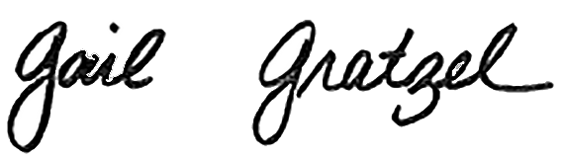
Gail Gratzel, MPH
Assistant Health Officer

